Code Coverage Report (under Salesforce Org Management)

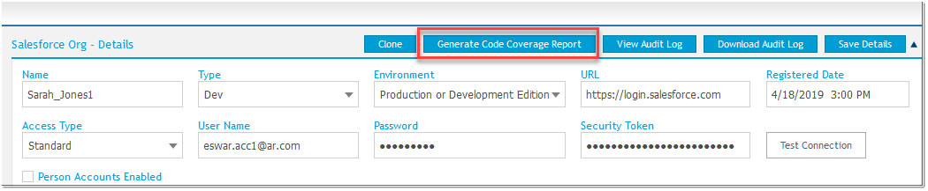

1. **Generate Code Coverage Report:** This function allows you to run all available Apex Test Class in the Salesforce org and generate code coverage report for the same. The code coverage report will be emailed to your registered email id with .CSV file attached. The .CSV file will contain the failed test classes that requires user attention to resolve them.

Attached are the sample email template that's will be notified to the user whenever the code coverage is run.

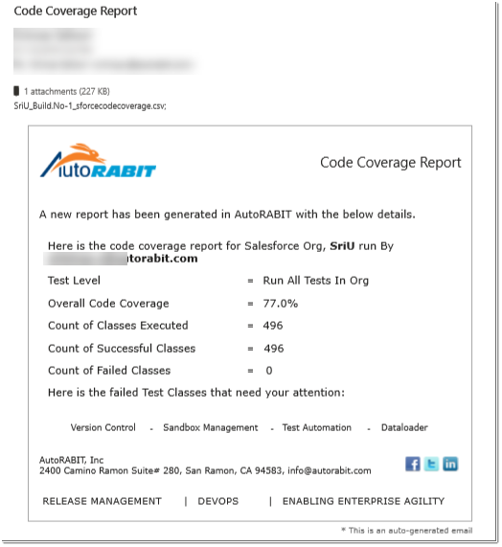

**Fig 1: *Code coverage Report with “0” failed classes***

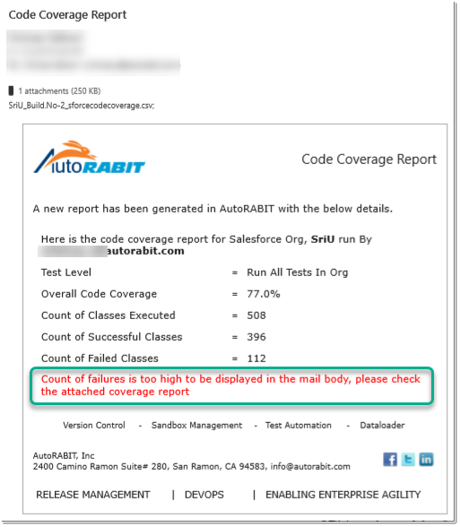

**Fig 2: *Code coverage Report with Test Classes failure count more than 20***

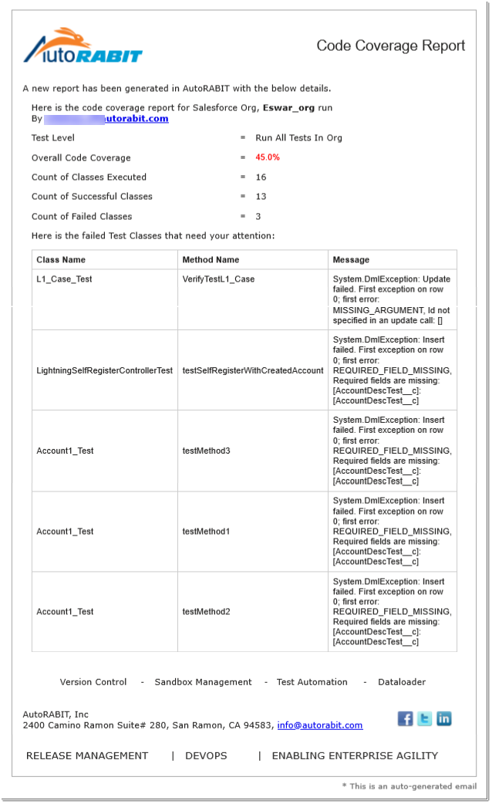

**Fig 3: *Code coverage Report with Test Classes failure count less than 20***

*(detailed error report will be included in the email body)*